SNOWFLAKE PERFORMANCE MANAGEMENT

DEDICATED VIRTUAL WAREHOUSE (user group / workload specific VWH)
Please check the previous post to understand i.e. snowflake_6
For example, if you go to any warehousing environment the structure is as follows
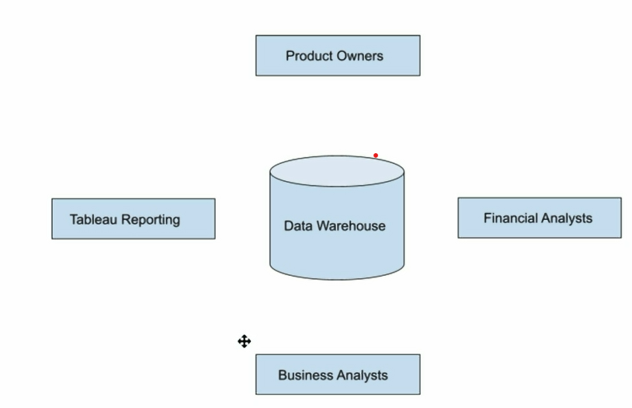
Various user groups (product owners, Business analysts etc.) will consume data from the data warehouse
Now the idea is to create a dedicated warehouses for each user group and identify the common workload (tableau reporting teams and BA’s might do same reporting)

Here are the steps while you create dedicated virtual warehouses:
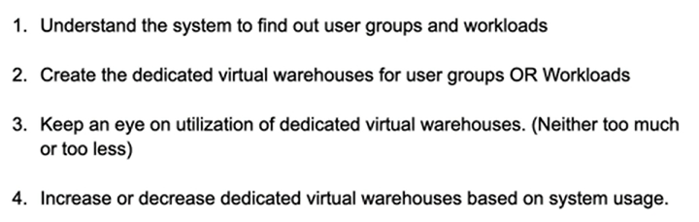

Let’s create a dedicated warehouse for Product Owners and Financial Analysts:
You can create a virtual warehouse by snowflake_2 post or if you want to create it by writing syntax, here it is
CREATE WAREHOUSE PRODUCT_OWNERS_WH
WITH WAREHOUSE_SIZE = 'SMALL'
WAREHOUSE_TYPE = 'STANDARD'
AUTO_SUSPEND = 600
AUTO_RESUME = TRUE
MIN_CLUSTER_COUNT = 1
MAX_CLUSTER_COUNT = 2
SCALING_POLICY = 'ECONOMY';

CREATE WAREHOUSE FINANCIAL_ANALYSTS_WH
WITH WAREHOUSE_SIZE = 'XSMALL'
WAREHOUSE_TYPE = 'STANDARD'
AUTO_SUSPEND = 600
AUTO_RESUME = TRUE
MIN_CLUSTER_COUNT = 1
MAX_CLUSTER_COUNT = 2
SCALING_POLICY = 'ECONOMY';

Create roles for above user groups. Use Account Admin to handle roles

Creating a role named product_owners_role and giving access to warehouse product_owners_wh
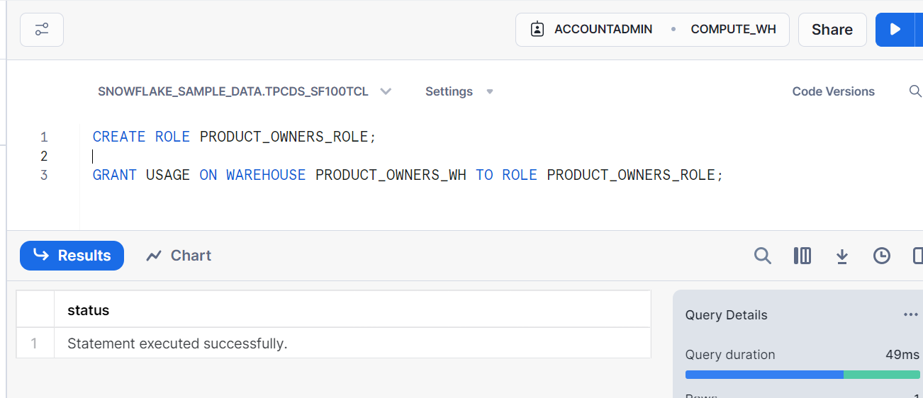
Creating a role named financial_analysts_role and giving access to warehouse financial_analysts_wh
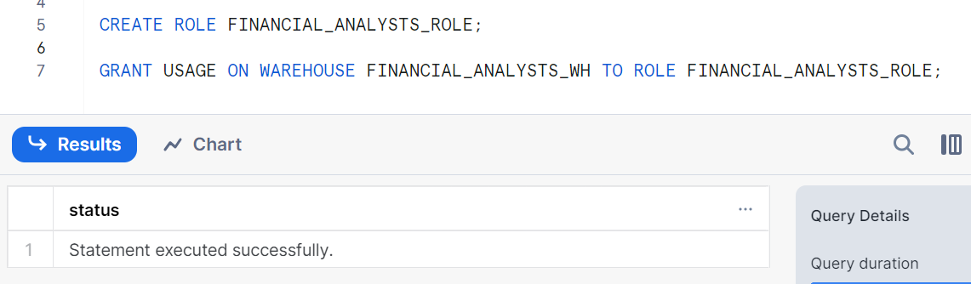
Now, creating some users
Product Owners - Adam, Smith, John, Alex

CREATE USER ADAM PASSWORD = 'ADAM'
LOGIN_NAME = 'ADAM'
DEFAULT_ROLE='PRODUCT_OWNERS_ROLE'
DEFAULT_WAREHOUSE = 'PRODUCT_OWNERS_WH'
MUST_CHANGE_PASSWORD = FALSE;

CREATE USER SMITH PASSWORD = 'SMITH'
LOGIN_NAME = 'SMITH'
DEFAULT_ROLE='PRODUCT_OWNERS_ROLE'
DEFAULT_WAREHOUSE = 'PRODUCT_OWNERS_WH'
MUST_CHANGE_PASSWORD = FALSE;

Note: creating users by giving login name, giving access to product_owners_role and warehouse product_owners_wh and with no password

Note: again separately granting access to product_owners_role to users
GRANT ROLE PRODUCT_OWNERS_ROLE TO USER ADAM;
GRANT ROLE PRODUCT_OWNERS_ROLE TO USER SMITH;
Show users;
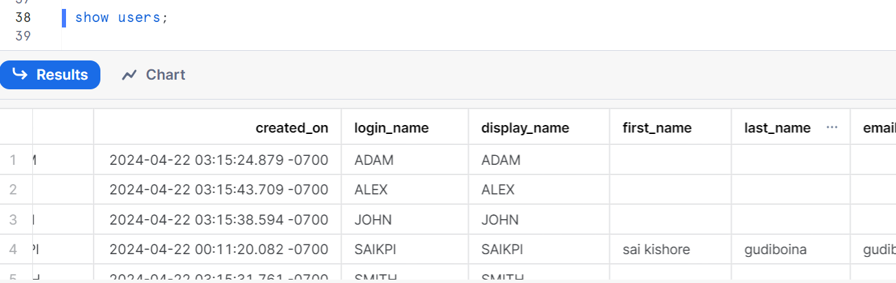
Can check user properties
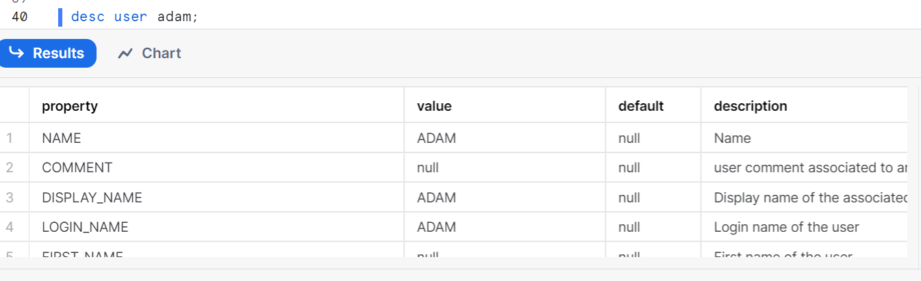
If you want to change the password of Adam, here is the step to do for writing syntax
ALTER USER ADAM RESET PASSWORD;
It generates a URL and click on it to change the password of Adam
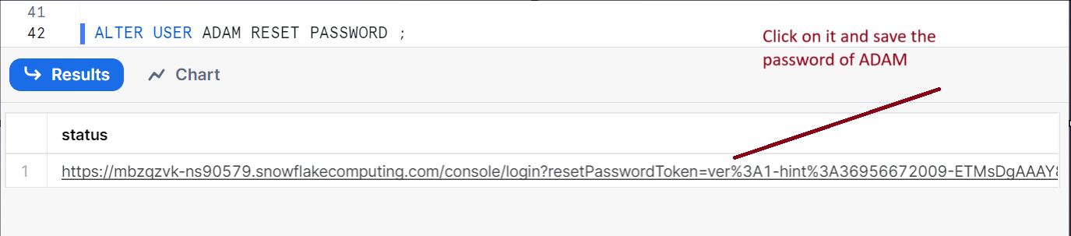

Similarly, do the same for financial analysts WH by creating users for bob, Jessica as above and give access to financial_analysts_role

Now, let’s check Adam’s user by signing in
First logout from your present account and sign in with user id and password as ‘ADAM’
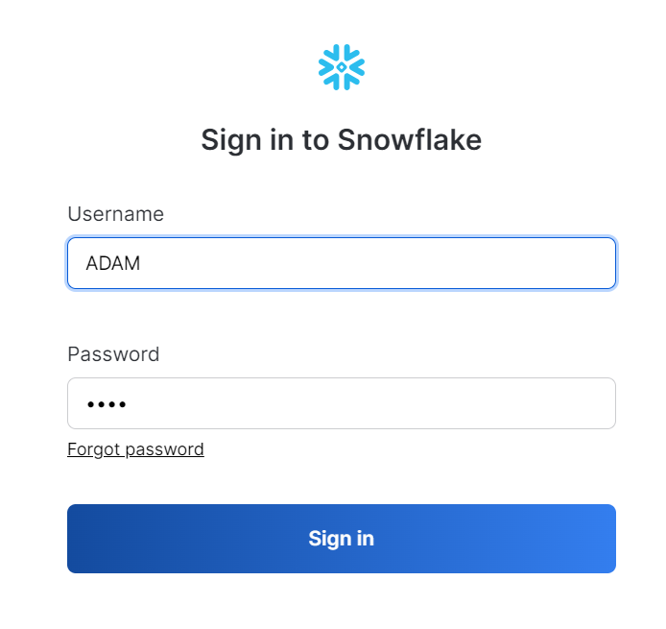

ADAM is assigned to product_owners_role ,here is image
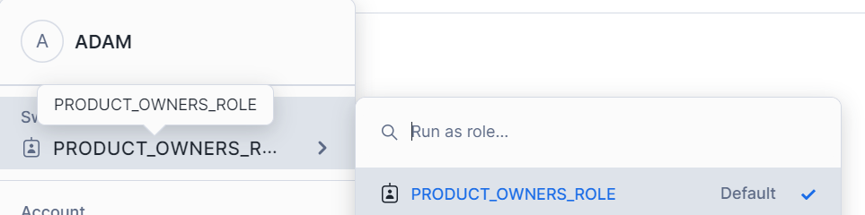

Go to admin and go to warehouses
U can see ADAM has access only to product_owners_WH

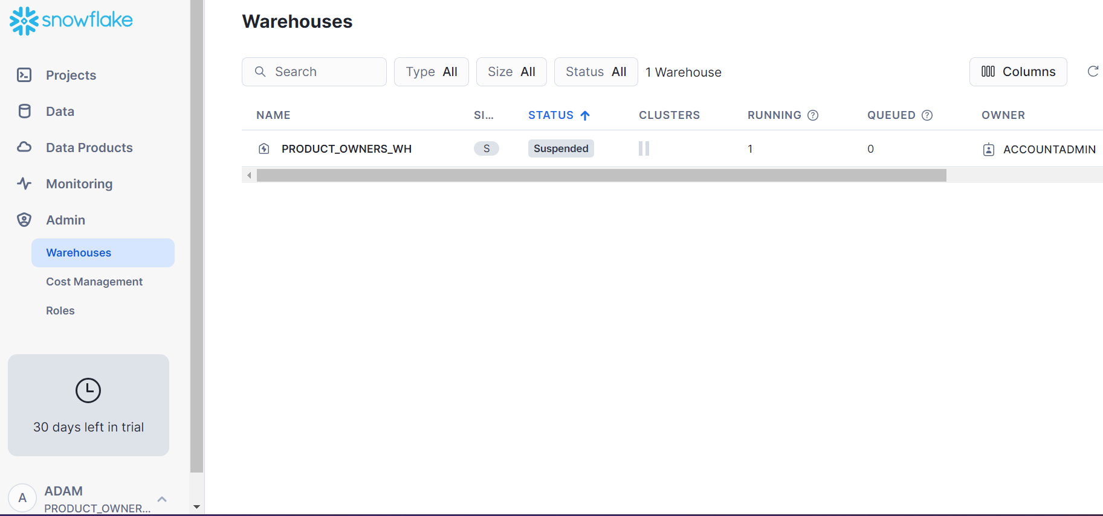

That’s where you create dedicated warehouses to users
User creates queries in worksheets that have Access to use only the warehouses

